**Experiment1.1**

**Student Name**: Himanshu **UID**: 20BCS7944

**Branch**: CSE  **Section**: 905/A

**Semester**: 6 **Date of Performance**: 15/02/2023

**Subject Name**: Data Mining Lab **Subject Code**: 20CSP-376

**1) Aim:**

Demonstration of preprocessing on .arff file using R Programming.

**2) Objective:**

To represent the creation of file using R Studio and displaying the pattern on Weka Tool for further extraction and analysis of knowledge.

**3) Code and Output:**

* Created a .arff file as -

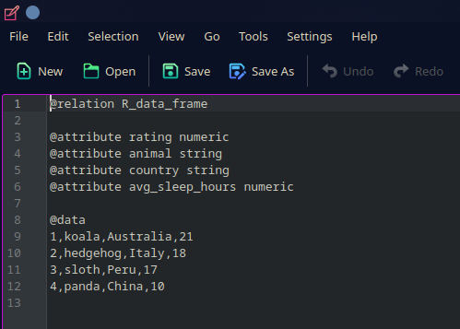

* Opened the file using Rweka -

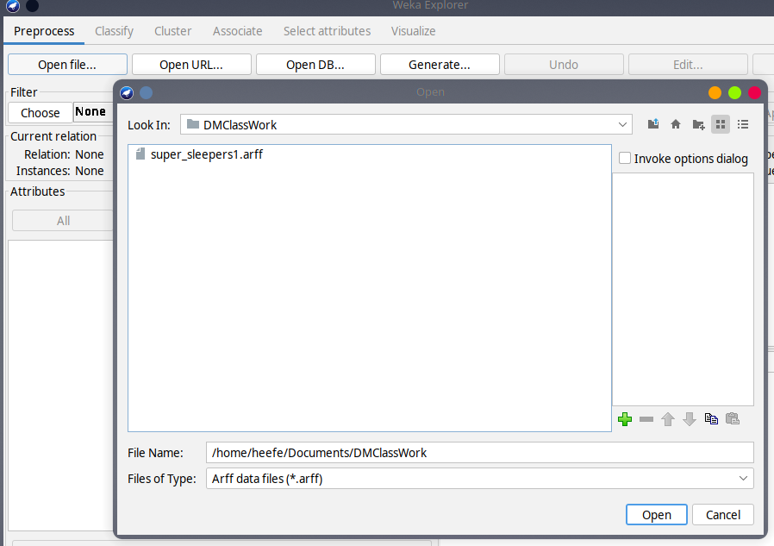

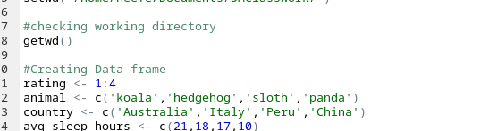

**Code -**

*library(RWeka)*

*setwd("/home/heefe/Documents/DMClassWork/")*

*getwd()*

*rating <- 1:4*

*animal <- c('koala','hedgehog','sloth','panda')*

*country <- c('Australia','Italy','Peru','China')*

*avg_sleep_hours <- c(21,18,17,10)*

*super_sleepers <- data.frame(rating,animal,country,avg_sleep_hours,stringsAsFactors = FALSE)*

*print(super_sleepers)*

*print(class(super_sleepers))*

*print(str(super_sleepers))*

*write.arff(super_sleepers,file("super_sleepers1.arff"))*

*N = read.arff("super_sleepers1.arff")*

*print(N)*

*print(head(N,2))*

*names(N)*

*N["animal"]*

Extracted information -

